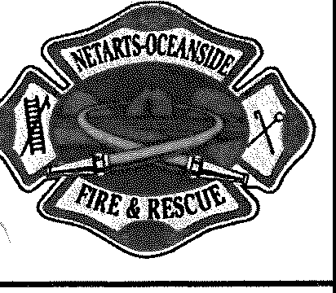
NETARTS-OCEANSIDE RURAL FIRE PROTECTION DISTRICT
January 9th, 2024 - Board of Directors Meeting Agenda

Date: Tuesday January 9th, 2024 Time: 18:00
Location: Netarts Fire Hall

BOARD MEMBERS:
Erin Rieger (Position 1, 2023 Vice President) Steve Roan (Position 2, 2023 - Secretary/ Treasurer) Brent Collier (Position 3, 2025 - Director)
DISTRICT ADMINISTRATION:
Tim Carpenter (Fire Chief) Shawna Yost VOLUNTEERS:

Scott Campbell (Position 4, 2025 - President)
Bruce Lovelin (Position 5, 2023 - Director) OTHERS:

Call to Order and Roll Call

- Open Joint meeting of the Netarts-Oceanside Fire District Board of Directors and the NOFD Contract Review Board.
- The purpose of this Joint public hearing is regarding joint resolution Number 24-01 amending public contracting rules for the Netarts-Oceanside Rural Fire Protection District.
(a)The public hearing is being held for the purpose of taking comments on the District’s draft findings supporting the exemption of certain classes of special procurements and public improvements contracts from competitive bidding requirements.
(b) Board questions
(c) Public Testimony.
3. Resolution
Joint Resolution number 24-01 of the Fire District Board and Local Contract Review Board Amending
Public Contracting Rules for the Netarts-Oceanside Rural Fire Protection District will read as follows.
READ RESOLUTION INTO MINUNTES
- Board Action Required
“I move to adopt Resolution number 24-01on behalf of the Netarts-Oceanside Rural Fire
Protection District”
4. ADJOURN JOINT MEETING OF THE FIRE DISTRICT/LOCAL CONTRACT REVIEW BOARD AND OPEN
REGULAR MONTHLY FIRE BOARD MEETING.

Communications:

Executive Session:
Resolutions:
Consent Agenda:
- Minutes - 12/12/2023 Board Meeting
- Finance Reports - See board packet.
- Fire Chief's Report -
- Board Member's Report -
- Volunteer Association Report -
- Safety Report -

Unfinished business:
- Finalize and Approve Fire Chief Job Description
- Finalize and Approve Fire Chief Salery and Benefits

New Business:
- Review and Approve Fire Chief Job Announcement

- ISO Public Protection Classification
- Review Fire Chief Policies

Committee Reports:
Pending Agenda Items: Training/Conferences/Seminars:
Next Board Meeting: February 13th 2024, 18:00 at Netarts Fire Hall

